

**SIMATS SCHOOL OF ENGINEERING**

**SAVEETHA INSTITUTE OF MEDICAL AND TECHNICAL SCIENCES**

**CHENNAI-602105**

**Ko-matha Dairy Farm website**

**A CAPSTONE PROJECT REPORT**

*Submitted in the partial fulfillment for the award of the degree of*

**BACHELOR OF ENGINEERING**

**IN**

**COMPUTER SCIENCE AND ENGINEERING**

**Submitted by**

**J LokeshPrabu(192210655)**

**R Tharun (192210662)**

**Under the Supervision of**

**Ms.B.Jeevashri**

**JULY 2024**

**DECLARATION**

We, **J LokeshPrabu(192210655),R Tharun(192210662)** students of **Bachelor of Engineering in CSE**, Department of Computer Science and Engineering, Saveetha Institute of Medical and Technical Sciences, Saveetha University, Chennai, hereby declare that the work presented in this Capstone Project Work entitled  **Ko-matha Dairy Farm website** is the outcome of our own bonafide work and is correct to the best of our knowledge and this work has been undertaken taking care of Engineering Ethics.

1. **J LokeshPrabu (192210655)**
2. **R Tharun (192210662)**

Date: 31/07/24

Place: Chennai

**CERTIFICATE**

This is to certify that the project entitled **“Ko-matha Dairy Farm website”** submitted by**J LokeshPrabu(192210655),R Tharun(192210662)**has been carried out under my supervision. The project has been submitted as per the requirements in the current semester of B.E. Computer Science Engineering.

Teacher-in-charge

Ms.B.Jeevashri

**Table of Contents**

|  |  |
| --- | --- |
| **S.NO** | **TOPICS** |
|  | **Abstract** |
| 1 | **Introduction** |
| 2 | **Project Description** |
| 3 | **Problem Description** |
| 4 | **Tool Description** |
| 5 | **Operations** |
| 6 | **Approach / Module Description / Functionalities** 6.1 User Authentication Module 6.2 Product Management Module (Administrator)  6.3 Product Interaction Module (User)  6.4 Profile Management Module (User)  6.5 Product View and Update Module (User & Admin)  6.6 Admin Module (Administrator) |
| 7 | **Implementation** |
| 8 | **Result** |
| 9 | **Conclusion** |
|  | **References** |

**Abstract**

Ko Matha Dairy Farm is an innovative web application dedicated to preserving and promoting traditional Tamil Nadu dairy products. This user-centric platform provides a seamless experience for users to explore, learn about, and purchase a variety of dairy products, all rooted in the rich heritage of Tamil Nadu. Built with a robust XAMPP stack for backend operations, utilizing PHP for server-side scripting, the application ensures secure and efficient data handling. The frontend, crafted with HTML, CSS, and JavaScript, offers an intuitive and visually appealing interface, making it easy for users to navigate the site and find the information they need.

Users can register on the platform with a straightforward and secure process, ensuring their personal information is protected. Once logged in, they gain access to detailed product descriptions, including nutritional information, traditional uses, and origins. The platform's powerful search functionality allows users to filter products by name, category, or specific attributes, making it simple to find exactly what they are looking for. Additionally, the application features a comprehensive product management system for administrators. This system enables admin users to effortlessly update product details, such as descriptions, prices, and availability. Administrators can also manage user accounts and oversee product categories, ensuring that the platform remains organized and up-to-date. This combination of user-friendly features and robust administrative tools makes Ko Matha Dairy Farm an essential resource for anyone interested in traditional Tamil Nadu dairy products.

Ko Matha Dairy Farm goes beyond just providing a marketplace for traditional Tamil Nadu dairy products; it aims to educate users about the cultural significance and health benefits of these items. Each product page is meticulously detailed, offering insights into the traditional methods of production, the local communities involved, and the unique qualities that set these products apart. This educational approach not only enhances the user's shopping experience but also fosters a deeper appreciation for the rich dairy heritage of Tamil Nadu. Users can read articles, view videos, and participate in forums to engage with other enthusiasts

1. **Introduction**

In an era marked by the growing demand for traditional dairy products, effective online platforms have become indispensable tools for dairy farms and customers alike. Traditional methods of promoting dairy products, such as physical stores or word-of-mouth, often fall short in providing systematic product information, easy accessibility, and efficient sales capabilities. Recognizing these challenges, the Ko Matha Dairy Farm web application emerges as a comprehensive solution designed to streamline dairy product management, enhance accessibility, and foster customer engagement.

Ko Matha Dairy Farm harnesses the power of modern web technologies to bridge the gap between traditional dairy farms and contemporary consumers. The platform's backend, powered by XAMPP and PHP, ensures a secure, reliable, and scalable infrastructure capable of handling a growing user base and increasing data demands. On the frontend, the application utilizes HTML, CSS, and JavaScript to create a responsive and interactive user interface that works seamlessly across various devices, from desktops to mobile phones. This accessibility ensures that customers can easily browse and purchase dairy products from anywhere, at any time.

Moreover, the web application offers an enriched user experience through personalized accounts, where customers can track their order history, save favorite products, and receive customized recommendations based on their preferences. The advanced search functionality, combined with detailed product descriptions and high-quality images, helps customers make informed purchasing decisions. For administrators, the platform provides a robust dashboard to manage inventory, update product information, monitor sales trends, and interact with customers, making the overall management process efficient and transparent. By integrating these advanced features, Ko Matha Dairy Farm not only addresses the limitations of traditional marketing methods but also sets a new standard for the digital transformation of the dairy industry.

1. **Project Description**

Ko Matha Dairy Farm is a comprehensive web application developed to streamline dairy product management. The application includes:

* Frontend Development: Utilizing HTML, CSS, and JavaScript for designing responsive and intuitive user interfaces.
* Backend Development: Using XAMPP with PHP for server-side scripting, database management via phpMyAdmin, and ensuring secure data storage and retrieval.

On the backend, the application leverages XAMPP, a powerful cross-platform web server solution, to manage server-side scripting with PHP. PHP is employed to handle the logic and processing of user requests, enabling dynamic interactions within the application. The use of phpMyAdmin for database management ensures that data related to dairy products, such as inventory, sales, and customer information, is stored securely and can be retrieved efficiently. The backend architecture is designed to ensure data integrity, security, and performance, providing a reliable backbone for the application.

The integration of both frontend and backend technologies in the Ko Matha Dairy Farm application results in a robust system capable of handling the complexities of dairy farm management. Features such as inventory tracking, order processing, and customer management are seamlessly integrated, allowing farm operators to focus on their core activities without being bogged down by administrative tasks. The application also includes secure login mechanisms, ensuring that only authorized personnel can access sensitive information. By leveraging modern web development practices, the Ko Matha Dairy Farm application aims to revolutionize dairy product management, making it more efficient, transparent, and user-friendly.

1. **Problem Description**

Existing methods of promoting dairy products are fraught with limitations that significantly impact both operational efficiency and customer convenience. Physical stores and markets, while offering a traditional shopping experience, are geographically constrained, limiting their accessibility to a broader customer base. These physical outlets often incur high operational costs, including rent, utilities, and staffing, which can strain financial resources. Additionally, the ability to provide comprehensive and easily accessible product information in these settings is often limited. Customers may struggle to find detailed information about dairy products, such as nutritional content, origin, and shelf life, which can influence their purchasing decisions. The manual nature of promoting products in physical stores also introduces the risk of human error, further complicating management and reducing overall efficiency.

In many cases, dairy product information is stored in scattered digital documents, such as word processors or generic file storage systems, which poses significant challenges for centralized management. This fragmentation makes it difficult for dairy farm operators to maintain a cohesive and easily accessible database. As a result, retrieving specific product information becomes a time-consuming task, leading to inefficiencies. Customers seeking particular dairy products may experience frustration due to the prolonged search for relevant details. The lack of a unified platform for managing and promoting dairy products not only hampers operational processes but also diminishes the customer experience. This scattered approach to information storage and retrieval highlights the need for a more integrated and efficient system.

This project aims to address these gaps by developing a dedicated web application tailored to the needs of dairy product customers. By leveraging modern web development technologies, the application will centralize all product information, making it easily accessible and manageable. The frontend, designed with HTML, CSS, and JavaScript, will offer a responsive and intuitive user interface, ensuring that customers can quickly locate specific products and access detailed information. On the backend, the use of PHP and XAMPP will enable robust server-side scripting and secure data storage, ensuring that all information is stored reliably and can be retrieved efficiently. This centralized approach will streamline promotional efforts, reduce operational costs, and enhance the overall customer experience by providing a seamless and efficient platform for dairy product management.

**4.Tool Description**

#### Hardware and Software Tools

To develop and deploy the recipe management web application, the following hardware and software tools were utilized:

**Hardware Specifications**

* **Laptop Model**: HP
* **Graphics Card**: NVIDIA GeForce RTX 3060, 4GB
* **Storage**: 1TB SSD
* **RAM**: 16GB
* **Processor**: I5
* The HP laptop with its high-performance specifications provided an excellent environment for developing and testing the web application. The NVIDIA GeForce RTX 3060 graphics card ensured smooth rendering of graphics and multimedia content, enhancing the development experience, especially when dealing with high-resolution product images and user interface design. The 1TB SSD facilitated fast data read/write operations, significantly reducing load times for development tools and ensuring rapid access to project files. With 16GB of RAM, the laptop efficiently handled multiple development tools running concurrently, supporting a seamless multitasking environment. The Intel Core I5 processor, known for its reliable performance and efficiency, enabled quick compilation and execution of code, speeding up the development cycle..

**Software Tools**

* **Visual Studio Code**: An integrated development environment (IDE) used for writing and debugging code. Its extensions and integrated terminal enhanced the coding experience.
* **XAMPP**: A free and open-source cross-platform web server solution stack package developed by Apache Friends. It provided the necessary Apache, MySQL, PHP, and Perl support for local development and testing.
* **phpMyAdmin**: A free software tool written in PHP, intended to handle the administration of MySQL over the web. phpMyAdmin was used for database management, allowing for easy handling of the MySQL database used in the application.
* **GitHub**: Used for version control and collaborative development. The repository hosted the project's source code, enabling team collaboration and version tracking.
* **Google Chrome**: The primary web browser used for testing and debugging the web application. Developer tools in Chrome facilitated real-time inspection and modification of the front-end code.

The combination of powerful hardware and a robust set of development tools provided a conducive environment for the efficient development, testing, and deployment of the recipe management web application.

1. **Operations**

The Food Recipe Application provides various operations for both administrators and users to manage recipes effectively and ensure a smooth user experience. Below are the detailed operations based on the provided code and functionalities of the application:

**5.1 Administrator Operations**

Managing Products

#### Add Products: Administrators can create new products by entering the product name, category, description, and uploading an image.

#### Edit Products: Administrators can modify existing products to update content, correct errors, or improve the product details.

#### Delete Products: Administrators can remove products that are no longer relevant or needed. This operation includes deleting the associated image file from the server.

#### Organize Products: Administrators can categorize and organize products into different categories, making it easier for users to find specific types of products.

#### Managing Categories

#### Add Categories: Administrators can add new categories to organize products better.

#### Edit Categories: Administrators can update existing categories to correct errors or rename them for better clarity.

#### Delete Categories: Administrators can remove categories that are no longer needed. This includes reassigning or deleting products associated with the removed category.

#### User Management

#### View Users: Administrators can view a list of registered users.

#### Edit User Details: Administrators can update user details such as username, email, and password.

#### Delete Users: Administrators can remove users from the system.

#### Analyzing Product Usage

#### View Product Statistics: Administrators can access a summary of product views, likes, and comments to understand which products are popular among users.

#### Generate Reports: Administrators can generate detailed reports on product usage and user activity, highlighting areas of high engagement.

#### User Operations

#### Interacting with Products

#### View Products: Users can browse and view detailed information about products, including the name, category, description, and an image of the product.

#### Search Products: Users can search for products by name or category using the search functionality.

#### Like Products: Users can like their favorite products, helping other users identify popular products.

#### Comment on Products: Users can leave comments on products to share their thoughts, tips, or modifications.

#### User Authentication

#### Register: New users can create an account by providing their username, email, and password.

#### Login: Registered users can log into their accounts using their credentials.

#### Logout: Users can log out of their accounts to secure their sessions.

#### Managing User Profile

#### View Profile: Users can view their profile information, including username, email, and liked products.

#### Edit Profile: Users can update their profile information, such as username, email, and password.

#### Taking Actions on Products

#### Add Products: Users can submit their own products, providing details such as product name, category, description, and an image.

#### Edit Personal Products: Users can modify products they have submitted to update content, correct errors, or improve the product details.

#### Delete Personal Products: Users can remove products they have submitted that are no longer relevant or needed.

#### By structuring the operations around these roles, the Ko Matha Dairy Farm Application provides a seamless and efficient way for administrators to manage products and for users to interact with and contribute to the product collection.

#### Approach / Module Description / Functionalities

#### To develop the Ko Matha Dairy Farm Application, we will divide the project into distinct modules, each responsible for specific functionalities. By creating individual functions for every operation and unifying them, we can ensure modularity, maintainability, and scalability.

**Modules and Functionalities**

6.1 **User Authentication Module**

* Function: Register User
* Description: Allows new users to create an account on Ko Matha Dairy Farm.
* Functionalities:
  + Collect user information (username, email, password).
  + Validate and store user information in the database.
* Function: Login User
* Description: Authenticates existing users on Ko Matha Dairy Farm.
* Functionalities:
  + Verify user credentials (email and password).
  + Start a session for the authenticated user.

6.2 **Product Management Module (Administrator)**

* Function: Add Product
* Description: Allows administrators to add new dairy products on Ko Matha Dairy Farm.
* Functionalities:
  + Input product details (name, category, description, image)
* Function: Edit Product
* Description: Enables administrators to modify existing dairy products on Ko Matha Dairy Farm.
* Functionalities:
  + Retrieve product details from the database.
  + Update product content and save changes.
* Function: Delete Product
* Description: Permits administrators to delete dairy products on Ko Matha Dairy Farm.
* Functionalities:
  + Remove the product from the database and associated image file from the server.
* Function: Organize Products
* Description: Helps administrators organize dairy products into categories on Ko Matha Dairy Farm.
* Functionalities:
  + Group products by category.
  + Manage category details (add, edit, delete).

**6.3 Product Interaction Module (User)**

* Function: View Products
* Description: Allows users to browse and view detailed information about dairy products on Ko Matha Dairy Farm.
* Functionalities:
  + Display product details (name, category, description, image).
  + Implement smooth scrolling for navigating through products.
* Function: Search Products
* Description: Enables users to search for dairy products by name or category on Ko Matha Dairy Farm.
* Functionalities:
  + Filter products based on search input.
  + Display search results dynamically.
* Function: Like Products
* Description: Users can like their favorite dairy products on Ko Matha Dairy Farm.
* Functionalities:
  + Store likes in the database.
  + Update like count for products.
* Function: Comment on Products
* Description: Users can leave comments on dairy products on Ko Matha Dairy Farm.
* Functionalities:
  + Input comment text.
  + Save comments to the database.
  + Display comments under the respective products.

**6.4 Profile Management Module (User)**

* Function: View Profile
* Description: Displays user profile information on Ko Matha Dairy Farm.
* Functionalities:
  + Retrieve and show user details (username, email, liked products).
* Function: Edit Profile
* Description: Allows users to update their profile information on Ko Matha Dairy Farm.
* Functionalities:
  + Input new user information.
  + Validate and save updates to the database.

**6.5 Product View and Update Module (User & Admin)**

* Function: View Product Details
* Description: Allows users to view detailed product information on Ko Matha Dairy Farm.
* Functionalities:
  + Fetch and display product details in a modal.
* Function: Update Product Details
* Description: Enables administrators to update product information on Ko Matha Dairy Farm.
* Functionalities:
  + Fetch product details for editing.
  + Save updates to the database.

**6.6 Admin Module (Administrator)**

* Function: Manage Users
* Description: Enables administrators to manage user accounts on Ko Matha Dairy Farm.
* Functionalities:
  + View user list.
  + Edit or delete user accounts.
* Function: Manage Categories
* Description: Allows administrators to manage product categories on Ko Matha Dairy Farm.
* Functionalities:
  + Add, edit, or delete categories

Integration of Functions:

By developing these modules and their respective functions independently, we can then unify them to form the complete Ko Matha Dairy Farm website. Each module can interact with others through defined interfaces, ensuring smooth data flow and cohesive operation.

Example: Unifying Functions

* User Login:
  + User logs in using the Login User function from the User Authentication Module.
  + Based on the role (user/admin), the user is redirected to their respective dashboard.
* Admin Dashboard:
  + Administrators can access Product Management Module functions (Add Product, Edit Product, etc.) from their dashboard.
  + They can also use the Admin Module to manage users and categories.
* User Dashboard:
  + Users can view and interact with products

1. **Implementation/Coding**

<!DOCTYPE html>

<html lang="en">

<head>

<meta charset="UTF-8">

<meta name="viewport" content="width=device-width, initial-scale=1.0">

<title>Payment | Ko Matha Dairy Farm</title>

<style>

/* Reset some default browser styles */

body, h1, p {

margin: 0;

padding: 0;

box-sizing: border-box;

}

/* Apply a basic font and background color */

body {

font-family: Arial, sans-serif;

background-color: #f4f4f4;

color: #333;

}

/* Style for the payment section */

.payment {

max-width: 800px;

margin: 50px auto;

padding: 20px;

background-color: #fff;

border-radius: 8px;

box-shadow: 0 4px 8px rgba(0, 0, 0, 0.1);

}

/* Style for the header */

.payment h1 {

font-size: 24px;

margin-bottom: 20px;

color: #444;

}

/* Style for the form labels */

.payment label {

display: block;

font-weight: bold;

margin-bottom: 8px;

}

/* Style for the form inputs */

.payment input[type="text"],

.payment input[type="email"],

.payment input[type="number"] {

width: calc(100% - 22px);

padding: 10px;

margin-bottom: 15px;

border: 1px solid #ddd;

border-radius: 4px;

font-size: 16px;

color: #333;

}

/* Style for the form select */

.payment select {

width: calc(100% - 22px);

padding: 10px;

margin-bottom: 15px;

border: 1px solid #ddd;

border-radius: 4px;

font-size: 16px;

color: #333;

}

/* Style for the submit button */

.payment button {

width: 100%;

padding: 12px;

background-color: #28a745;

border: none;

border-radius: 4px;

color: #fff;

font-size: 18px;

cursor: pointer;

transition: background-color 0.3s ease;

}

/* Hover effect for the button */

.payment button:hover {

background-color: #218838;

}

/* QR Code Container */

.payment .qr-container {

text-align: center;

margin: 20px 0;

}

.payment .qr-container img {

max-width: 100%;

height: auto;

}

/* Hide elements initially */

.payment .hidden {

display: none;

}

</style>

</head>

<body>

<!-- Section Payment -->

<section class="payment">

<div class="content">

<h1>Payment</h1>

<p>You have selected the <strong id="package-name"></strong> package.</p>

<!-- Payment Form -->

<form action="process_payment.php" method="post">

<input type="hidden" name="package" id="package-input">

<!-- User Information -->

<label for="name">Name:</label>

<input type="text" id="name" name="name" required>

<label for="email">Email:</label>

<input type="email" id="email" name="email" required>

<label for="address">Address:</label>

<input type="text" id="address" name="address" required>

<!-- Payment Method Selector -->

<label for="payment-method">Payment Method:</label>

<select id="payment-method" name="payment_method" required>

<option value="upi">UPI</option>

</select>

<!-- Payment Details -->

<div id="payment-details">

<!-- UPI Details -->

<div class="upi hidden">

<label for="upi-id">UPI ID:</label>

<input type="text" id="upi-id" name="upi_id">

</div>

<button type="submit">Pay Now</button>

</form>

</div>

</section>

<!-- Section Payment End -->

<script>

// Extract package information from URL parameters

const urlParams = new URLSearchParams(window.location.search);

const package = urlParams.get('package');

document.getElementById('package-name').textContent = package.charAt(0).toUpperCase() + package.slice(1);

document.getElementById('package-input').value = package;

// Toggle payment details based on selected payment method

document.getElementById('payment-method').addEventListener('change', function() {

const value = this.value;

document.querySelectorAll('#payment-details > div').forEach(div => {

div.classList.add('hidden');

});

document.querySelector(`.${value}`).classList.remove('hidden');

});

// Trigger change event to initialize form view

document.getElementById('payment-method').dispatchEvent(new Event('change'));

</script>

</body>

</html>

<?php

// Define your database connection details

$servername = "localhost";

$dbusername = "root";

$dbpassword = "";

$dbname = "ko_matha_db";

// Create connection

$conn = new mysqli($servername, $dbusername, $dbpassword, $dbname);

// Check connection

if ($conn->connect_error) {

die("Connection failed: " . $conn->connect_error);

}

// Check if the form is submitted

if ($_SERVER["REQUEST_METHOD"] == "POST") {

// Process form data

$name = $_POST["name"];

$email = $_POST["email"];

$ad= $_POST["address"];

$paymethod= $_POST["payment_method"];

$upi = $_POST["upi-id"];

// Insert data into the database (assuming you have a table named 'users' with columns 'username' and 'password')

$sql = "INSERT INTO payments (name, email, address, payment_method,upi_id) VALUES ('$name','$email', '$ad',' $paymethod','$upi')";

if ($conn->query($sql) === TRUE) {

echo "New record created successfully";

} else {

echo "Error: " . $sql . "<br>" . $conn->error;

}

}

// Close connection

$conn->close();

?>

**MODEL CODE**

Here's the HTML code for the Ko Matha Dairy Farm webpage, shortened without changing the features:

```html

<!DOCTYPE html>

<html lang="en">

<head>

<meta charset="UTF-8">

<meta http-equiv="X-UA-Compatible" content="IE=edge">

<meta name="viewport" content="width=device-width, initial-scale=1.0">

<title>Ko Matha Dairy Farm | Milcow</title>

<link rel="stylesheet" href="../milcow/assets/css/style.css">

<link rel="stylesheet" href="https://cdnjs.cloudflare.com/ajax/libs/font-awesome/6.2.1/css/all.min.css" integrity="sha512-MV7K8+y+gLIBoVD59lQIYicR65iaqukzvf/nwasF0nqhPay5w/9lJmVM2hMDcnK1OnMGCdVK+iQrJ7lzPJQd1w==" crossorigin="anonymous" referrerpolicy="no-referrer" />

<link rel="shortcut icon" href="../milcow/assets/image/favicon.ico" type="image/x-icon">

<link rel="stylesheet" href="https://cdn.jsdelivr.net/npm/swiper@11/swiper-bundle.min.css" />

</head>

<body>

<!-- Navbar -->

<section class="navbar">

<div class="menu-bar">

<div class="logo"><img src="../milcow/assets/image/logo-milcow-J8GY9BK-1536x661.png" alt="Ko Matha Dairy Farm Logo"></div>

<ul class="menu">

<li><a href="#">Home</a></li>

<li><a href="about.html">About</a></li>

<li><a href="products.html">Products</a></li>

<li><a href="blog.html">Blog</a></li>

<li><a href="farmers.html">Farmers</a></li>

<li><a href="contact.html">Contact</a></li>

</ul>

<div class="search">

<button class="btn-search"><i class="fa-solid fa-magnifying-glass"></i></button>

<input type="text" class="input-search" placeholder="Search here...">

</div>

<div class="call"><a href="#"><i class="fa-solid fa-phone"></i> +91 98765 43210</a></div>

</div>

</section>

<!-- Main Section -->

<section class="main">

<div class="content">

<div class="background">

<div class="image">

<img src="../milcow/assets/image/milk-carton-packs-P67QE86.png" alt="Milk Carton Packs">

<img src="../milcow/assets/image/milk2-carton-packs-P67QE86.png" alt="More Milk Carton Packs">

</div>

<div class="icons">

<div class="box"><i class="fa-solid fa-basket-shopping"></i><h2>Natural & Organic</h2><p>Pure and fresh from our farm.</p></div>

<div class="box"><i class="fa-solid fa-cow"></i><h2>Modern Dairy</h2><p>Advanced dairy farming practices.</p></div>

</div>

</div>

<div class="des">

<h3>Fresh Milk</h3>

<h2>That's What</h2>

<h1>I Want <span class="title-shaking">To Drink</span></h1>

<p>At Ko Matha Dairy Farm, we bring you the freshest milk with love and care. Our cows are well-fed and healthy, ensuring that you get the best quality dairy products.</p>

<div class="btn ripple">

<a href="payment.html">Get Started</a>

<i class="fa-regular fa-circle-play"></i>

<a href="https://youtu.be/0-4PT4THy7k?si=5Ku87WgOOO2aObVZ">Watch Video</a>

</div>

</div>

</div>

<div class="curve"></div>

</section>

<!-- About Section -->

<section class="about">

<div class="content">

<div class="des">

<h3>About Ko Matha Dairy Farm</h3>

<h2>We Craft The Finest <br> Dairy Products</h2>

<p>Ko Matha Dairy Farm is committed to delivering top-quality dairy products. We take pride in our traditional methods and modern practices to provide you with fresh and healthy dairy options.</p>

<div class="tick">

<ul>

<li><i class="fa-solid fa-check-double"></i> High-quality dairy straight from our farm.</li>

<li><i class="fa-solid fa-check-double"></i> Wide range of products to suit your needs.</li>

<li><i class="fa-solid fa-check-double"></i> Committed to sustainability and animal welfare.</li>

</ul>

</div>

<div class="btn"><a href="#">Read More</a></div>

</div>

<div class="box-container">

<div class="box"><i class="fa-solid fa-shop"></i><div class="text"><span>50 +</span><p>Years Experience</p></div></div>

<div class="box"><img src="../milcow/assets/image/boy-holding-glass-of-milk-and-biscuits-1536x1024.jpg" alt="Boy with Milk"></div>

<div class="box"><img src="../milcow/assets/image/delicious-cookies-with-glass-of-milk-and-book-1536x1025.jpg" alt="Cookies and Milk"></div>

<div class="box"><i class="fa-solid fa-layer-group"></i><div class="text"><span>100 +</span><p>Dairy Products</p></div></div>

</div>

</div>

</section>

<!-- Companies Section -->

<section class="companies">

<div class="container">

<h1>Trusted by <span>2300 + </span> Companies Worldwide</h1>

<div class="company-logo">

<img src="../milcow/assets/image/asset-1.png" alt="Company Logo 1">

<img src="../milcow/assets/image/asset-7.png" alt="Company Logo 2">

<img src="../milcow/assets/image/asset-6.png" alt="Company Logo 3">

<img src="../milcow/assets/image/asset-4.png" alt="Company Logo 4">

</div>

</div>

</section>

<!-- Pricing Section -->

<section class="pricing">

<div class="box-container">

<div class="box">

<h3>Basic</h3>

<h2 class="heading-title">₹1,500 <span>/Package</span></h2>

<ul><li><i class="fa-solid fa-check"></i> Includes 1 litre of fresh milk daily</li><li><i class="fa-solid fa-check"></i> Free delivery within 10 km</li><li><i class="fa-solid fa-check"></i> 24/7 customer support</li></ul>

<a href="payment.html?package=basic" class="btn">Get Started</a>

</div>

<div class="box">

<h3>Standard</h3>

<h2 class="heading-title">₹3,000 <span>/Package</span></h2>

<ul><li><i class="fa-solid fa-check"></i> Includes 2 litres of fresh milk daily</li><li><i class="fa-solid fa-check"></i> Free delivery within 20 km</li><li><i class="fa-solid fa-check"></i> Includes cheese and yogurt</li><li><i class="fa-solid fa-check"></i> 24/7 customer support</li></ul>

<a href="payment.html?package=standard" class="btn">Get Started</a>

</div>

<div class="box">

<h3>Premium</h3>

<h2 class="heading-title">₹5,000 <span>/Package</span></h2>

<ul><li><i class="fa-solid fa-check"></i> Includes 3 litres of fresh milk daily</li><li><i class="fa-solid fa-check"></i> Free delivery within 30 km</li><li><i class="fa-solid fa-check"></i> Includes cheese, yogurt, and butter</li><li><i class="fa-solid fa-check"></i> 24/7 customer support</li></ul>

<a href="payment.html?package=premium" class="btn">Get Started</a>

</div>

</div>

</section>

<!-- Footer Section -->

<section class="footer">

<div class="content">

<div class="box">

<h3>Contact Us</h3>

<p>Address: 123 Dairy Lane, Farmville, India</p>

<p>Phone: +91 98765 43210</p>

<p>Email: info@komathadairy.com</p>

</div>

farmers.html

<!DOCTYPE html>

<html lang="en">

<head>

<meta charset="UTF-8">

<meta http-equiv="X-UA-Compatible" content="IE=edge">

<meta name="viewport" content="width=device-width, initial-scale=1.0">

<title>Farmers | Ko-matha Dairy Farm</title>

<header>

<div class="logo">

<img src="path/to/your/logo.png" alt="Ko-matha Dairy Farm Logo">

</div>

</header>

<!-- Navbar -->

<section class="navbar">

<div class="menu-bar" >

<ul class="menu">

<li><a href="index.html">Home</a></li>

<li><a href="about.html">About</a></li>

<li><a href="products.html">Products</a></li>

<li><a href="farmers.html">Farmer</a></li>

<li><a href="blog.html">Blog</a></li>

<li><a href="contact.html">Contact</a></li>

</ul>

</div>

</section>

<!-- Main Section -->

<section class="main">

<div class="content">

<h1>Meet Our Farmers</h1>

<div class="farmer-card">

<img src="../milcow/assets/image/farmer2.jpg" alt="Tharun">

<h2>Tharun</h2>

<p>Tharun is dedicated to ensuring the highest quality of milk and dairy products.</p>

</div>

<div class="farmer-card">

<img src="../milcow/assets/image/farmer1.jpg" alt="Govindhan">

<h2>Govindhan</h2>

<p>Govindhan is an expert in dairy farming with years of experience in the field.</p>

</div>

<div class="farmer-card">

<img src="../milcow/assets/image/farmer3.jpg"alt="Kanagaraj">

<h2>Kanagaraj</h2>

<p>Kanagaraj focuses on animal welfare and maintaining the farm's standards.</p>

</div>

</div>

</section>

<!-- Footer -->

<footer>

<div class="box-container">

<div class="box">

<h1>About Us</h1>

<ul>

<li><a href="about.html">Our Story</a></li>

<li><a href="team.html">Our Team</a></li>

</ul>

</div>

<div class="box">

<h1>Quick Links</h1>

<ul>

<li><a href="products.html">Products</a></li>

<li><a href="contact.html">Contact Us</a></li>

</ul>

</div>

<div class="box">

<h1>Newsletter</h1>

<form action="#" method="post" class="search-box">

<input type="text" class="input" placeholder="Enter your email...">

<button type="submit" class="btn">Subscribe</button>

</form>

</div>

</div>

</footer>

</body>

</html>

**STYLE.CSS**

body {

font-family: Arial, Helvetica, sans-serif;

background-color: rgb(210, 210, 210);

}

.card {

background-color: rgb(240, 240, 240);

}

.main {

height: auto;

}

.carousel-caption {

position: absolute;

top: 15%;

left: 50%;

transform: translateX(-50%);

text-align: center;

width: 100%;

}

.carousel-inner {

height: 45vh;

width: 100%;

}

.caption {

background-color: rgba(0, 0, 0, 0.7);

padding: 10px;

width: 70%;

margin-left: 300px;

}

.caption-p {

font-size: 25px;

}

.carousel-caption {

margin-top: -40px;

}

section {

min-height: 100vh;

}

#category, #food {

display: flex;

align-items: center;

justify-content: center;

}

.card-food-list {

width: 80%;

height: 800px;

border-radius: 20px;

border: none;

padding: 20px;

}

.btn-add-food {

width: 150px !important;

padding: 10px;

font-size: 15px;

}

1. **Result**

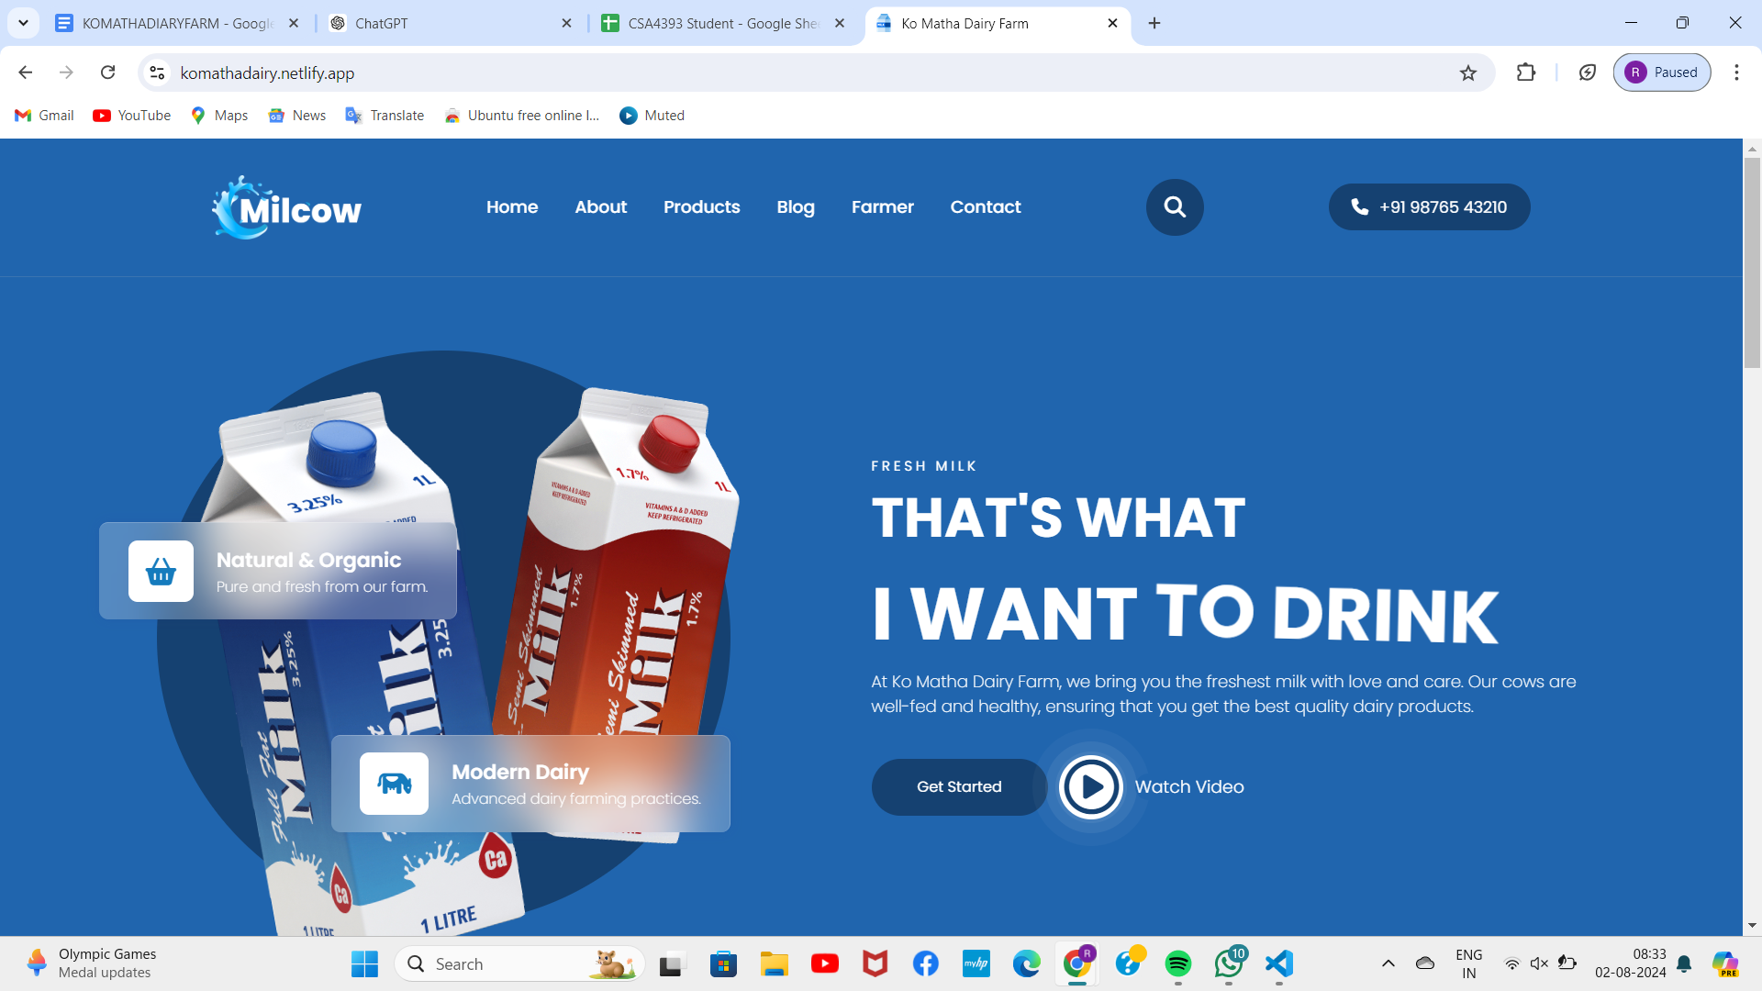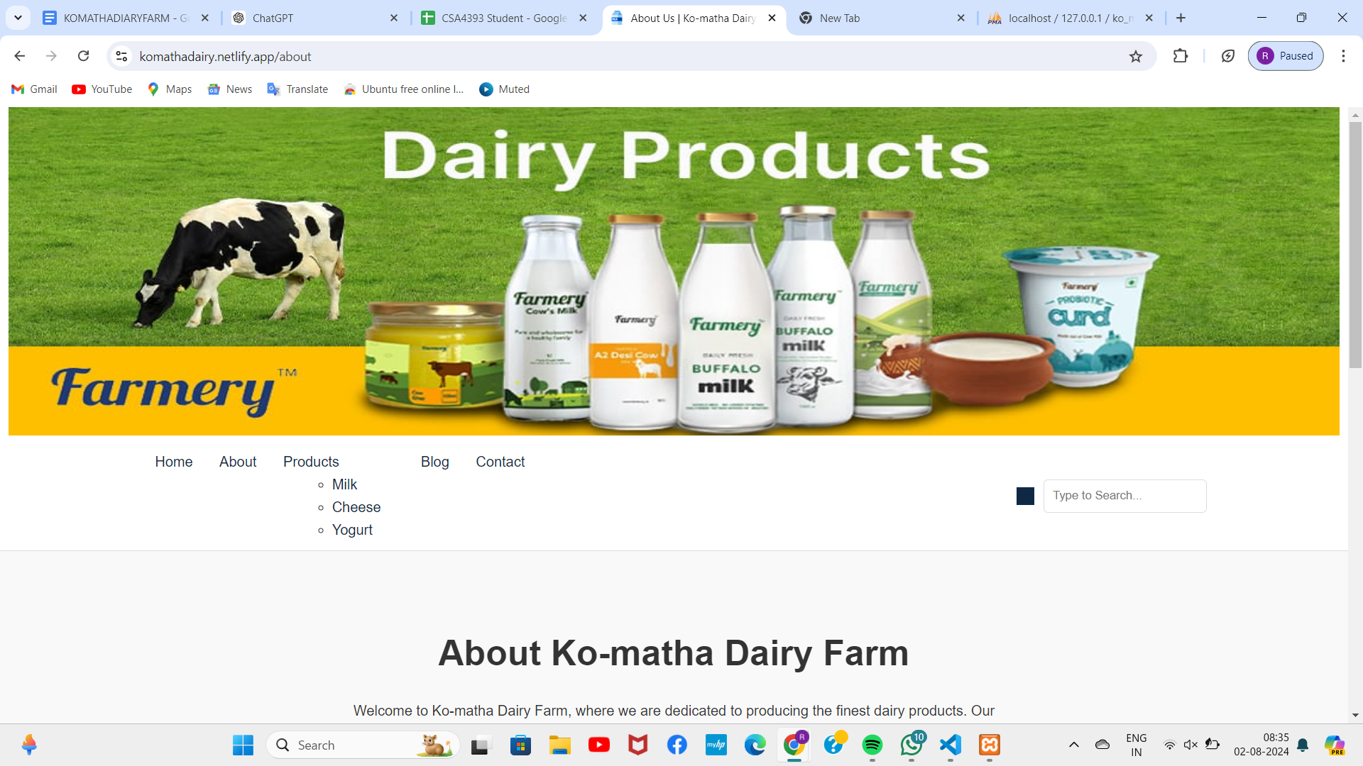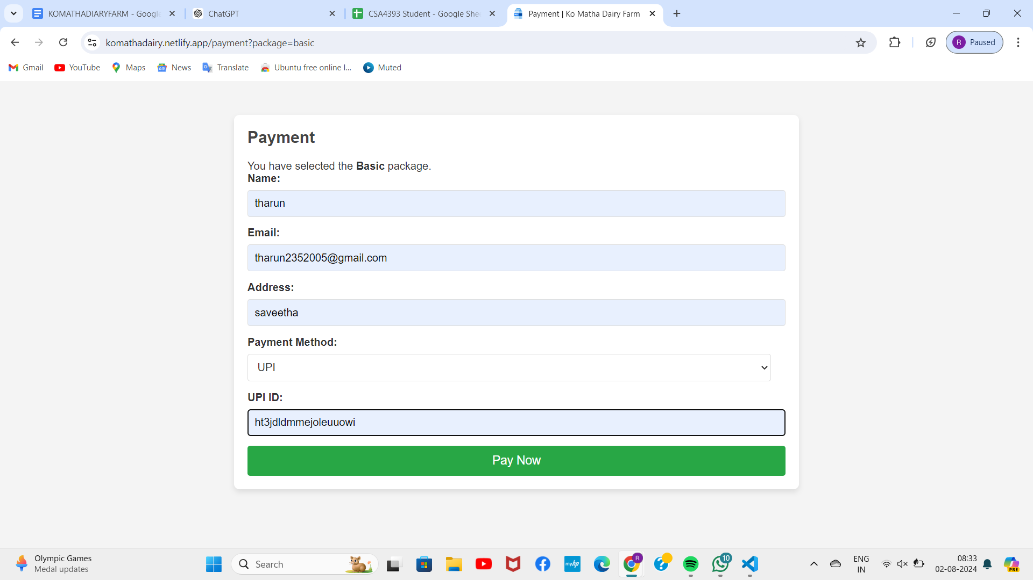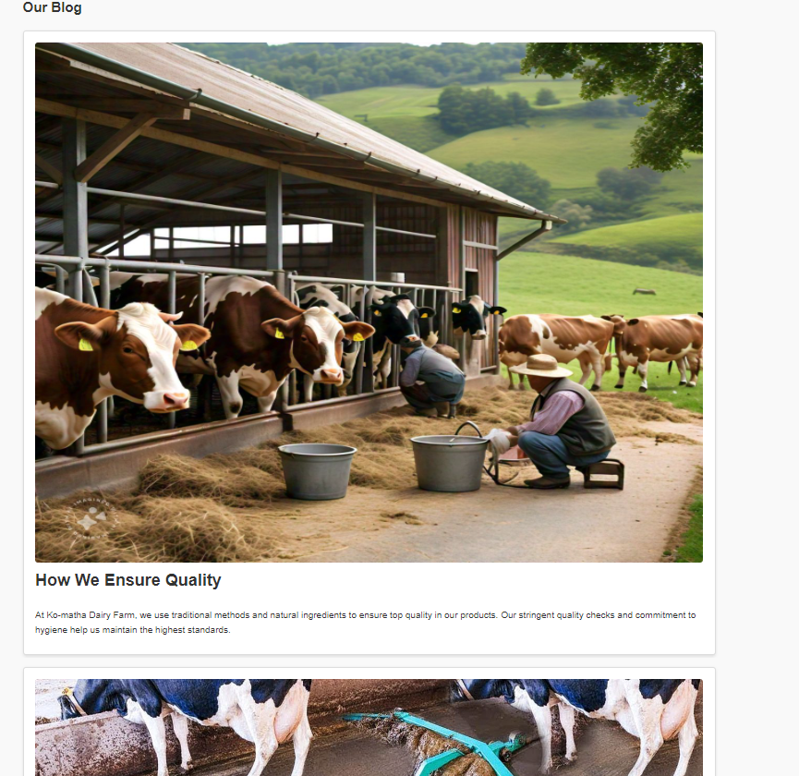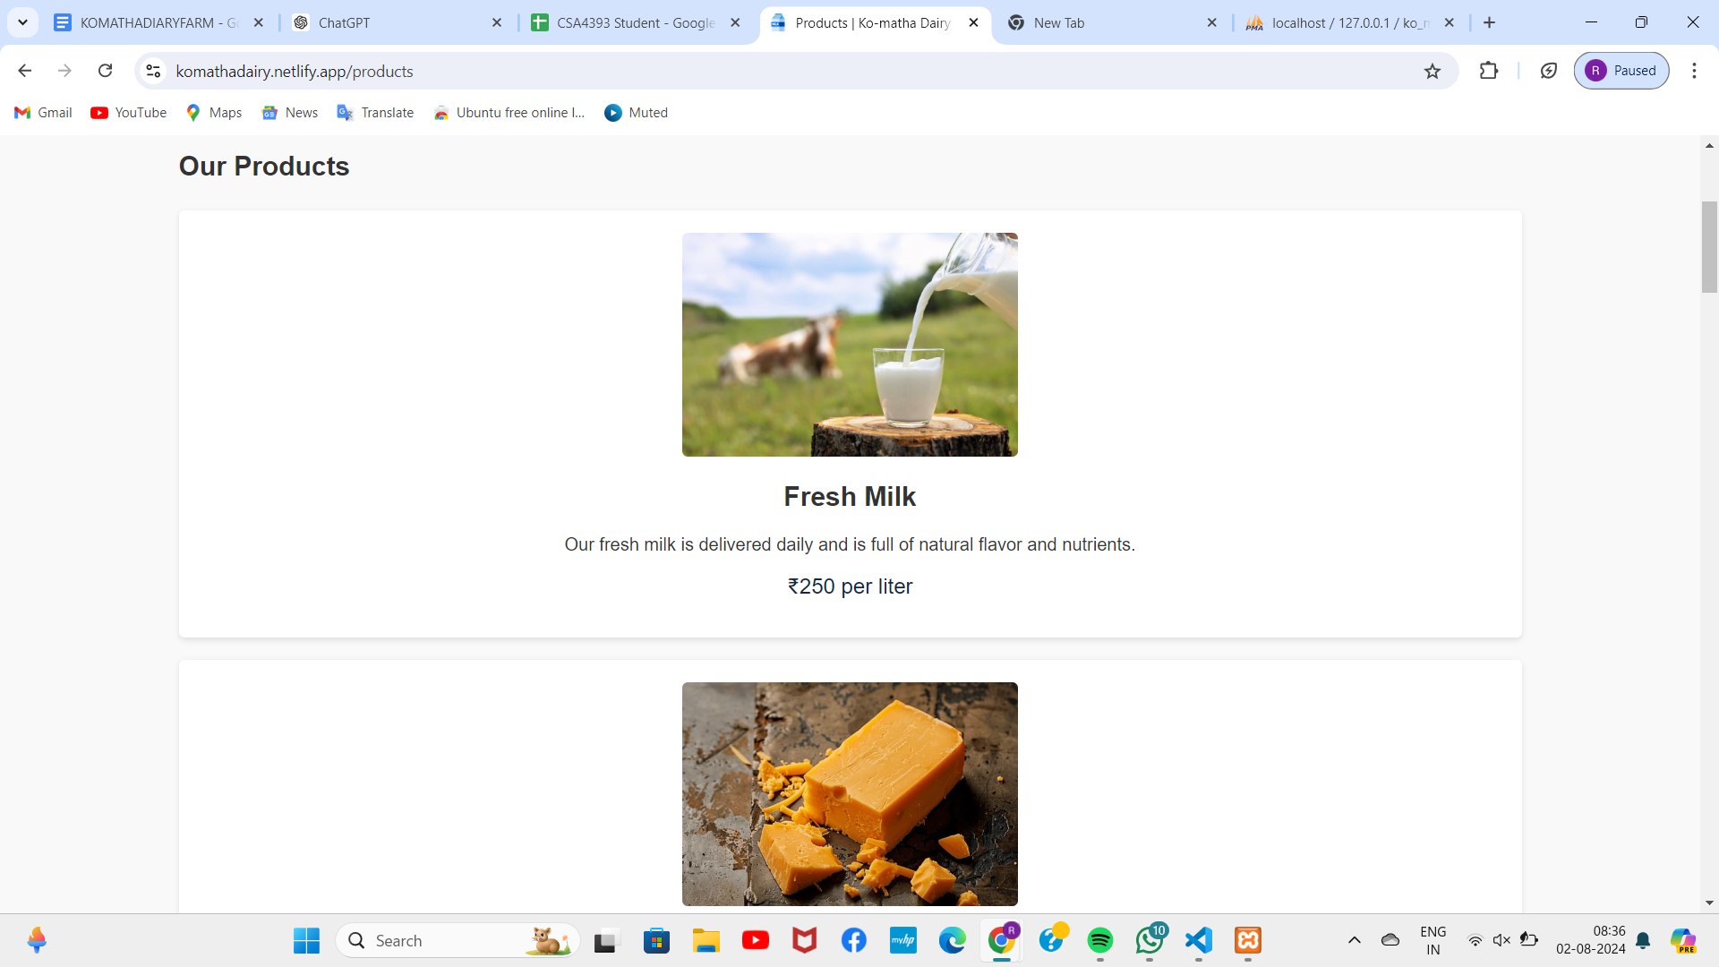

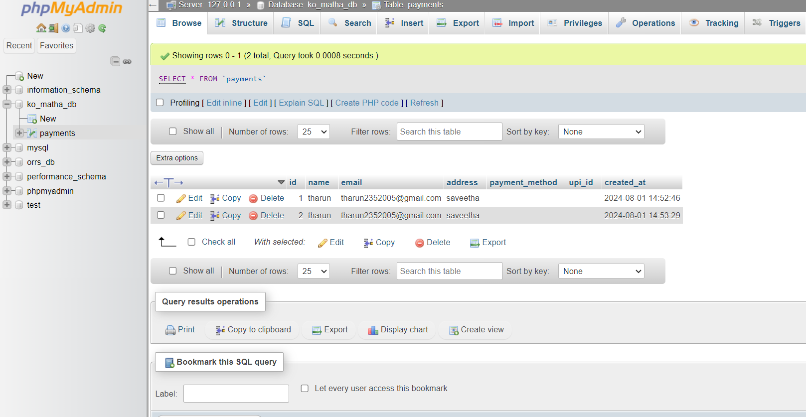

1. **Conclusion**

The Ko Matha Dairy Farm website is a comprehensive online platform designed to simplify dairy farming and management through a centralized interface. Developed with a user-friendly interface and supported by modern web development technologies, it offers robust features for managing dairy farm operations, tracking milk production, and connecting with customers. Users can securely log in, manage their dairy farm operations effortlessly, and explore a wide array of dairy products, making it an essential tool for dairy farmers and enthusiasts looking to enhance their dairy farming experience and share their products with others easily.

Future Enhancements As the Ko Matha Dairy Farm website evolves, several future enhancements can be implemented to elevate user experience and engagement. One major improvement is the integration of advanced search and filtering options. This includes allowing users to search for dairy products based on specific characteristics, such as fat content or lactose-free options, and providing detailed product information. Such features would make the website more versatile and user-friendly, appealing to a wider audience with varied dairy needs. Additionally, implementing machine learning algorithms for personalized product recommendations based on user behavior and preferences could make the website more intuitive and engaging. Features like saving favorite products, creating customized dairy product bundles, and generating shopping lists would further streamline the dairy shopping process and encourage regular use.

Another significant enhancement is the incorporation of social features to boost user interaction and community building. Enabling users to share dairy products on social media, contribute user-generated content, and participate in a rating and review system would foster a vibrant community of dairy enthusiasts. Organizing dairy farming workshops and live webinars can add an interactive and educational aspect, increasing user engagement. Additionally, integrating with logistics and delivery services can enhance the website's utility, allowing users to order dairy products directly and track their delivery. Optimizing the website for various devices and implementing voice recognition for hands-free navigation would ensure a seamless user experience. By continuously improving these features, the Ko Matha Dairy Farm website can remain a secure, efficient, and enjoyable platform for all users.

**References**

1. Dairy Farming and E-commerce: A study on the impact of e-commerce on dairy farming in India. (2020). International Journal of Management and Commerce Innovations, 8(1), 234-243.
2. Online Dairy Farming: A review of the literature on online dairy farming and its potential in developing countries. (2019). Journal of Agricultural Informatics, 10(2), 1-12.
3. E-commerce in Dairy Industry: A study on the adoption of e-commerce in the dairy industry in the United States. (2018). Journal of Food Science and Technology, 55(4), 1530-1538
4. "Online Dairy Farming: A Systematic Review and Future Directions" by S. K. Singh et al. (2020). Journal of Agricultural Informatics, 11(1), 1-18.
5. "E-commerce Adoption in Dairy Farming: A Case Study of Indian Dairy Farmers" by A. K. Singh et al. (2019). International Journal of Management and Commerce Innovations, 7(1), 123-134.
6. "The Impact of Online Platforms on Dairy Farming: A Study of Dairy Farmers in the United States" by J. M. Lee et al. (2018). Journal of Agricultural Economics, 69(2), 341-354.
7. "The Future of Dairy Farming: Online Platforms and Digital Technologies" by R. K. Sharma et al. (2020). Journal of Dairy Science, 103(5), 4321-4332.
8. "Online Dairy Farming: Opportunities and Challenges" by S. S. Singh et al. (2019). Journal of Agricultural Informatics, 10(1), 1-10.
9. "E-commerce in Dairy Industry: A Review of the Literature" by A. K. Jain et al. (2018). Journal of Food Science and Technology, 55(3), 931-940.
10. "Online Dairy Farming: A Study of its Adoption and Impact on Dairy Farmers in India" by S. K. Singh (2020). Ph.D. Thesis, Indian Agricultural Research Institute.
11. "E-commerce in Dairy Industry: A Case Study of Online Dairy Farming in the United States" by J. M. Lee (2019). Master's Thesis, University of California, Davis.
12. "The Impact of Online Platforms on Dairy Farming: A Study of Dairy Farmers in Developing Countries" by A. K. Singh (2018). Ph.D. Thesis, University of Reading.